Running head: ARM MOVEMENTS AND LOCATION ESTIMATION

ARM MOVEMENT AS A CUE FOR THE ESTIMATION OF VISUAL LOCATION

WLADIMIR KIRSCH AND WILFRIED KUNDE
Department of Psychology, University of Würzburg, Germany

Summary.-- Two experiments including twenty-four (M_{age} = 29 years, SD = 9, six males) and twenty-five participants (M_{age} = 27 years, SD = 9, eight males) respectively examined how arm movement extent affects the perception of visual locations. Linear arm movements were performed on a horizontal plane from a start position until an auditory signal occurred. Subsequently, the position of a visual target located along the movement path was judged. The target was judged as further away with an increase in movement extent. Results indicated that motor-related signals are taken into account in visual perception of locations. There were no indications though that changes of location perception prompt subsequent changes of action planning, which demonstrates the short-term nature of action-induced plasticity of space perception under the present conditions.
It is widely accepted that the visual system integrates several types of information about an object’s distance, such as occlusion, relative size, convergence, and accommodation (see e.g., Cutting & Vishton, 1995 for a review). A recent line of research demonstrates, however, that changes in visual perception not only result from changes in optical and oculomotor cues but also from variations of certain variables related to the body and its movements (see Proffitt, 2008; Witt, 2011; Proffitt & Linkenauger, 2013 for reviews and, e.g., Firestone, 2013 for criticism).
For example, when hand movements with large (as compared with small) amplitude are planned, distances in grasping space are judged as larger (e.g., Kirsch, Herbort, Butz, & Kunde, 2012; Kirsch & Kunde, 2013a; Kirsch & Kunde, 2013b). This effect was measured by means of a matching procedure depicted in Figure 1. Participants were asked to judge spatial intervals in depth (sagittal plane) by adjusting spatial intervals in a frontoparallel plane (perpendicular to the line of sight). An increase in the amplitude of hand movements planned along the sagittal plane was associated with an increase in distance estimates. This result indicated that some variables relating to the planning of movement extent affect the perception of space. However, it is not clear at present which specific spatial features are affected by the variation of movement amplitude. Motor variables could alter either the perceived distance between two objects or the perceived locations of those objects (or both) under the mentioned conditions.
--------- Figure 1 about here ---------
The main purpose of the present study was to scrutinize influences of movement amplitude on perceived object location. If distances and locations are considered in Euclidian coordinate systems, then asking observers about the locations of two objects is equivalent to asking them about the distance between those objects. However, psychologically, distances and locations are actually not interchangeable (e.g., Loomis, Da Silva, Philbeck, & Fukusima, 1996). For example, a relative distance between two objects can be derived without egocentric localization of those objects (Gogel, 1963). Also, distance and location information are differently susceptible to visual illusions (Abrams & Landgraf, 1990). This indicates that a motor variable can have differential impacts on distance and location perception. Consider, e.g., an observer who moves a cup of coffee from location “A” to location “B” (e.g., from the bottom to the top location in Figure 1). He could possibly indicate that the apparent distance between these locations increases as the weight of the cup increases (cf Kirsch & Kunde, 2013a). However, this possible change in the perception of relative (i.e., “exocentric”) distance would not necessarily imply changes in the perception of each location (i.e., of egocentric distances to the locations A and B). Hence, asking observers about objects’ distances and objects’ locations reflects two dissociable aspects of space perception. At present it is unknown if both these aspects of space are affected by changes in the amplitude of hand movements.
It is well known that the perception of an object’s location is subject to diverse distortions. For example, when asked to indicate the final location of a moving stimulus participants’ judgments often shift in the direction of motion (Freyd & Finke, 1984). Also, static stimuli presented in the retinal periphery are perceived as more foveal than they actually are (e.g., van der Heijden, van der Geest, de Leeuw, Krikke, & Müsseler, 1999). Beyond stimulus properties both phenomena depend on cognitive factors including observer’s expectancies, intentions and attentional focus (e.g., Hubbard, 1995; Jordan, Stork, Knuf, Kerzel, & Müsseler, 2002; Bocianski, Müsseler, & Erlhagen, 2010). Moreover, there is evidence that indicates a close link between these phenomena and the control of eye movements and thus, suggests an impact of motor processes on the perception of an object’s location (Müsseler, van der Heijden, Mahmud, Deubel, & Ertsey, 1999; Kerzel, 2000; Kerzel, Jordan, & Müsseler, 2001; Stork, Müsseler, & van der Heijden, 2010). Against this background it seems well conceivable that the perception of an object’s location can vary as a function of the amplitude of concurrently performed hand movements.
In the present study, participants were asked to move a stylus along a linear trajectory toward a visual target on a digital pad and to stop moving the stylus after they heard a tone. Then, the current target location was judged. The tone occurred so that the stylus movement could be stopped substantially before the target, near the target, or substantially behind the target. It has been hypothesized that if movement information is indeed included in the estimation of target location, the target should be judged as being located further away with an increase in movement extent (Hypothesis 1).
In Experiment A, visual feedback of the current stylus position was continuously presented during the movements (but not during the judgment). Therefore, visual consequences of the movement may be responsible for possible effects on judgment behavior, rather than movement extent per se. In particular, the visual feedback of the current stylus position can serve as an anchor during the estimation of target location and can affect the judgement irrespective of the real stylus position (or real movement extent). In this case, a potential effect would be visual in nature and would not be directly related to the actual movement. To assess the potential contribution of such movement consequences, a second experiment (B) was conducted in which the visual feedback of the stylus position was omitted. Finding an increase in the location estimates with an increase in movement extent in Experiment A but not in Experiment B will raise doubts whether this effect is directly related to motor variables. Otherwise (i.e., if the effect of interest is present in both experiments) an impact of motor variables on location perception will be supported.
Beyond this primary issue the present design allowed us to explore if motor-related changes of perceived object location prompt subsequent changes of action execution. Such changes of behavior are assumed in action-specific approaches to perception (Proffitt, 2006; Witt, 2011). Altered perception is considered to induce adaptive behavior, such that, for example, a hunter who sees a prey as small because of low current aiming capabilities moves closer towards the prey to increase hunting success. Here this issue was addressed by trial to trial correlational analyses. The study analyzed whether the variation in movement amplitude among subsequent trials is partly or even fully mediated by changes of perceived object location. In essence, movement amplitude in a given trial (n) was correlated with the movement amplitude in a preceding trial (n-1). This was made to access possible adjustments of the current movement which are due to the movement of the previous trial. Then, the same analysis was performed using location judgments in trial n-1 as a control variable. Thus, it has been examined whether current movement adjustments can be explained by the preceding judgment behavior. If perceptual changes indeed affect subsequent behavior as suggested (see above) then holding the location judgments constant should decrease the inter-movement correlation (Hypothesis 2).

Method
Participants. Twenty-four right handed participants participated in Experiment A (M_{age} = 29 years, SD = 9, six males) and twenty-five right handed participants participated in Experiment B (M_{age} = 27 years, SD = 9, eight males). They were recruited by means of advertisements distributed through a local e-mail distribution list (including potential participants), a social network, or a local online-newspaper. Five participants of Experiment B also participated in Experiment A. They gave their informed consent for the procedures and received an honorarium or course credit for their participation.
Apparatus. The main apparatus consisted of a graphics tablet (Intuos 4 XL, Wacom), a digitizing stylus, a monitor and a semi-silvered mirror. A monitor was mounted above a table on which the tablet was placed. The monitor-tablet distance was about 47 cm. The mirror prevented the vision of the hand in a dimmed lab and allowed projections of virtual images in the plane of the tablet. It was mounted in the middle between the monitor and the tablet. One pixel (px) of the monitor measured approximately 0.38 mm. Headphones were used for the presentation of acoustic signals.
Procedure and design. Participants sat in front of the apparatus so that their body midline was approximately in the middle of the monitor and of the tablet. They were asked to lean their forehead on an upper part of the apparatus during the experiment in order to reduce head movements. Stylus movements were performed with the right hand. Perceptual estimations were made with the left hand using a conventional keyboard placed to the left of the apparatus.
Figure 2 outlines the basic trial procedure and the arrangement of stimuli. At the beginning of each trial participants were asked to move a stylus on the graphics tablet along a linear trajectory toward a visual target (gray dot, ~ 2 mm in size) that remained visible throughout the trial until the judgment was finished (see below). After a certain distance was covered an acoustic signal was presented (a sequence of short beep tons, 2000 Hz). Participant’s task was to stop the movement in response to this signal, to press a stylus key located at the bottom part of the stylus (near the tip) and to keep the stylus in the stopped position. The key press turned the sound off. Subsequently, the position of the (still visible) target was judged by means of two comparison stimuli (gray lines, 5.7 mm in length) which were presented 70.3 mm to the left of the target. The lines were 0.38 mm thick and 1.52 mm apart from each other. The participant was asked to press a button on the keyboard to indicate which of the two lines was closer to the position of the target. Pressing of the upper/lower arrow key changed the color of the further/closer line from gray to yellow. The position estimate was confirmed by the enter key. In response to this key press the target and the comparison lines disappeared and the start position appeared. This was a signal to move the stylus back to the start position that was constant through the experiments.
--------- Figure 2 about here ---------
Participants were encouraged to perform rather slow movements and to stop the movement immediately after the stop signal. An error feedback was presented and the current trial was repeated when the stylus key was pressed before the stop position was reached or when the distance between the end position of the stylus and the position at which the stop signal was presented exceeded 38 mm. In those cases, the following text appeared at the screen for 1000 ms (in German): “Error! You made a wrong movement. The trial will be repeated”.
Experiment A and Experiment B differed only in visual feedback accompanied forward movements of the stylus. In Experiment A, the current stylus position was continuously presented during the forward movement (green dot, 2 mm in size). Note, however, after movement stopping (i.e., before the position judgment) the feedback disappeared. In Experiment B, forward movements were performed in the absence of visual feedback. In both experiments, the current stylus position was displayed during the backward movement when the y-distance between the stylus and the start position fell below 38 mm.
There were three possible target positions. Related to the y-coordinate the target was located either approximately in the middle between the two comparison lines (middle target), .76 mm above the further line (far target) or .76 mm below the closer line (close target). That is, the distance between the start and the comparison stimuli was constant (149.72 and 151.24 mm), whereas the start-target distance varied (148.96, 150.48, and 152 mm). This stimulus configuration ensured that the task was not too easy for the participant and thus, offered the possibility to capture a possible impact of movement amplitude on location estimates.
The distance at which the stop signal occurred (related to the y-coordinate) was varied so that the stylus movement could be stopped from substantially before the target, via near the target, through substantially behind the target. This stop distance was chosen based on previous similar experiments (unpublished) and amounted to 90.44, 115.52, 140.60, 165.68 and 190.76 mm. It took into account an expected delay between the stop signal and the end point of the movement. As shown in APPENDIX, this manipulation was successful. That is, participants stopped the movement near the target in the middle stop condition and successively further away with an increase and a decrease in stop distance.
The experiments included thus two independent variables: target position (3 levels) and stop distance (5 levels). Each experiment consisted of three blocks with 60 trials each. In each block, each combination of target position and stop condition was presented four times in a randomized order. At the beginning of each experiment participants performed 8 practice trials, which were not included in the analyses.
Data preprocessing, dependent variables and analyses. Trials in which movement amplitude was below or above 2 SD of the median as computed for each participant, each target and each stop condition were excluded from analysis. This outlier procedure served to improve the intended manipulation of movement amplitude. Overall, 95.1 % (Exp. A) and 95.0 % (Exp. B) of trials entered the analyses.
The primary dependent variable was the percentage of choices of the further comparison stimulus. These percentage values were transformed to arcsine values (e.g., Sokal & Rohlf, 1981) and were then analyzed using an analysis of variance (ANOVA) with target position and stop distance as within-subjects factors.
Besides measuring judgment behavior some movement parameters indicating motor planning and control strategies were also accessed. “Movement amplitude” was measured as a difference between the y-coordinate of the start position and the y-coordinate of the stylus after pressing the stylus key following the stop signal. “Movement time until the stop signal” was defined as a time difference between defined movement onset (exceeding 5.7mm in respect to the start position) and the time at which stop signal was presented. “Reaction time after stop signal” was the interval between the onset of the stop signal and the pressing of the stylus key.
These parameters can be considered as complementary in the present context and are indicative of current movement planning processes. Planning a far movement is typically associated with a larger force impulse than planning a shorter movement (e.g., Gordon & Ghez, 1987; Messier & Kalaska, 1999). Accordingly, movement times until the stop signal in a given trial should be slower for movements which are planned according to a closer endpoint. Also, stopping a movement planned according to a far end point can be assumed to be more difficult. Thus, the reaction time after the stop signal as well as the current movement amplitude can be assumed to increase for movements planned according to a far end point as compared with movements planned according to a close end point.
According to this rationale all three parameters basically capture the velocity of the movement which depends on the preprogrammed force. In theory, online control processes can also contribute to these measures. This, however, would not substantially limit the conclusions relating to the question of interest (see below).
An initial analysis aimed to detect possible adjustments of current motor behavior depending on the previous trial. For this purpose two closer and two further stop conditions were pooled and the selected movement parameters were averaged according to whether the stop categories were repeated or switched in successive trials. Then, ANOVAs including target position, movement type (i.e., stop category) and trial type (repetition, switch) as factors were performed for each movement parameter.
Subsequently, a correlation analysis was performed in order to test whether such motor adjustments are due to the judgment behavior observed in the previous trial as suggested by action specific accounts of perception (see Introduction). For this purpose, partial correlations were computed between movement amplitudes of subsequent trials by using target distance in trial n-1, stop distance and target distance in trial n as control variables. This analysis was performed for each participant and captured (similarly to the initial ANOVA approach, see above), an impact of movement amplitude of a previous trial (n-1) on movement amplitude in a given trial (n). In other words, the analysis aimed to access to the current variability in movement amplitude which is not due to the conditions of the current trial but due to the movement variability of the previous trial. It was then assumed that if judgment in a previous trial prompts the motor behavior in a given trial, then these correlations should vanish when judgments in trial n-1 will be included as an additional control variable.

Results
The main results are shown in Figure 3. An increase in target distance resulted in an increase in the preference of the further comparison stimulus. An analysis of variance (ANOVA) including target position and stop distance as factors revealed a significant main effect of target position for Exp. A, F(2, 46) = 112.08, p < .001, η_{p}² = .830, and for Exp. B, F(2, 48) = 59.28, p < .001, η_{p}² = .712. More importantly, an increase of movement extent was associated with an approximately linear increase in the preference of the further comparison stimulus as predicted. That is, participants judged the target stimulus as further away the larger the amplitude of the preceding movement was. A significant main effect of stop distance was observed for Exp. A, F(4, 92) = 4.15, p = .004, η_{p}² = .153, as well as for Exp. B, F(4, 96) = 3.70, p = .008, η_{p}² = .134. There were no significant interactions (p >. 08). Moreover, a linear contrast of factor stop distance was significant in both experiments with F(1, 23) = 6.92, p = .015, η_{p}² = .231 and F(1, 24) = 5.02, p = .035, η_{p}² = .173.
--------- Figure 3 about here ---------
Figure 4 shows movement amplitude, movement time until the stop signal, and the reaction time after the stop signal as a function of pooled stop distance in the current and in the previous trial. Movement amplitude was shorter after short than after large movements. Movement time until the stop signal, in contrast, tended to increase after short movements. Reaction times after the stop signal in a given trial tended to be faster when short movements were performed in a preceding trial. The analyses (ANOVAs) including target position, movement type (i.e., stop category) and trial type (repetition, switch) as factors yielded a significant interaction between movement type and trial type for movement amplitude, F(1, 23) = 13.39, p = .001, η_{p}² = .368 (Exp. A) and F(1, 24) = 9.63, p = .005, η_{p}² = .286 (Exp. B), for the movement times, F(1, 23) = 22.98, p < .001, η_{p}² = .500 (Exp. A) and F(1, 24) = 13.00, p = .001, η_{p}² = .351 (Exp. B), as well as for the reaction times, F(1, 23) = 5.69, p = .026, η_{p}² = .198 (Exp. A) and F(1, 24) = 18.84, p < .001, η_{p}² = .440 (Exp. B). These results suggested that participants planned a smaller / larger movement when a preceding movement was rather small / large. Thus, changes in target perception following the variation of movement amplitude seemed to go along with adjustments of the planning and control of the subsequent movement.
--------- Figure 4 about here ---------
To further examine such a possible relationship the movement amplitude in trial n was initially correlated with movement amplitude in trial n-1 while target distance in trial n-1, stop distance and target distance in trial n served as control variables. Mean correlation coefficients observed in Experiment A and Experiment B were positive and significantly different from zero, r = .159, t(23) = 9.13, p < .001 (Exp. A), and r = .191, t(24) = 9.03, p <.001 (Exp. B). Then, judgments in trial n-1 were included as an additional control variable. The correlation coefficients did not substantially change and were not significantly different from those observed in the initial analysis, r = .161, t(23) = .33, p = .744 (Exp. A), and r = .195, t(24) = .81, p =.426 (Exp. B). These results thus suggested that adjustments of motor behavior in a subsequent trial following varying movement amplitude in the previous trial were unaffected by participants’ judgment made in the previous trial.

Discussion
The present study showed that visual targets were judged as being located further away the larger the amplitude of a concurrent arm movement was. This result extended previous findings and suggested that visual perception of object location is codetermined by the extent of currently executed hand movements. We consider this outcome as further evidence for a close relation between perception and action put forward by several researchers from different domains (e.g., Proffitt & Linkenauger, 2013; Müsseler & van der Heijden, 2004; Hommel, Müsseler, Aschersleben, & Prinz, 2001; Jordan, 1998; Nijhawan, 2002).
The specific mechanisms involved in the present and similar tasks are not clear at present. The results suggest that some motor information related to the hand movement and visual signals are integrated at a certain stage of processing. However, which motor variable, e.g., might be capable to affect the judgment of target location has not been examined in the present study. Previous research indicated that final arm position (or posture, Kirsch & Kunde, 2013b) as well as shifts of spatial attention accompanying movement planning and control (Bocianski, et al., 2010; Müsseler & Tiggelbeck, 2013; Kirsch, 2015) are suitable candidates to fulfill this function.
One important feature ascribed to actions’ effects on perception is their adaptive function that consists in preparation for a potential action by signaling opportunities and costs associated with that action (e.g., Proffitt, 2006; Witt, 2011). This study provided no evidence for such adaptive changes. It was observed, however, that action execution in a given trial affected action execution in the next trial, but these correlations did not change when changes in perception were taken into account. Perhaps such changes were in fact not very adaptive under the conditions studied here given that the movement was externally stopped at varying locations. In other words changes of action planning that are mediated by altered perception might occur with more stable action requirements. Consider, e.g., a walker experiencing an increase in perception of walking distance while wearing a heavy backpack. Deciding to walk this (subjectively rather large) distance might prompt the mobilization of additional resources in order to safely reach the target place.
These conclusions should be considered with caution. Since the endpoint of the movement did not correspond with the visual positon of the target in most cases, an assumption of a type of direct mapping between movement and visual signals might be not appropriate. Instead, an interaction on a rather abstract cognitive level may possibly explain the results. For example, the variation of movement amplitude might have been accompanied by differences in the activation of concepts such as “far” and “close”. These concepts might have had an impact on perception, rather than some low-level processes related to movement planning and control. Alternatively, the results can be indicative of an impact of motor variables on judgments behavior rather than on perception (e.g., Firestone, 2013). The present experiments cannot overcome these limitations. Accordingly, more research is needed to tackle these rather complex issues and to better understand the nature of motor effects in perceptual tasks.
To sum up, the present study demonstrated that movement extent affects the perception of visual locations. Moreover, the results showed that following perceptual changes the behavior is adjusted consistent with the direction of the presumably changed perception. There were, however, no indications that changes of perception prompt subsequent changes of action planning in the present setup.

References
Abrams, R. A., & Landgraf, J. Z. (1990) Differential use of distance and location information for spatial localization. Perception & Psychophysics, 47(4), 349-359.

Bocianski, D., Müsseler, J., & Erlhagen, W. (2010) Effects of attention on a relative mislocalization with successively presented stimuli. Vision Research, 50, 1793-1802.

Cousineau, D. (2005) Confidence intervals in within-subject designs: A simpler solution to Loftus and Masson's method. Tutorials in Quantitative Methods for Psychology, 1, 75-78.

Cutting, J. E., & Vishton, P. M. (1995) Perceiving layout and knowing distances: The integration, relative potency, and contextual use of different information about depth. In W.
Epstein & S. Rogers (Eds), Handbook of perception and cognition. Vol 5; Perception of space and motion. SanDiego, CA: Academic Press. Pp. 69-117.

Firestone C. (2013) How “paternalistic” is spatial perception? Why wearing a heavy backpack doesn’t—and couldn’t—make hills look steeper. Perspectives on Psychological Science, 8, 455–473.

Freyd, J. J., & Finke, R. A. (1984) Representational momentum. Journal of Experimental Psychology: Learning, Memory, and Cognition, 10, 126-132.

Gogel, W. C. (1963) The visual perception of size and distance. Vision Research, 3, 101-120.

Gordon, J., & Ghez, C. (1987) Trajectory control in targeted force impulses. II. Pulse height control. Experimental Brain Research, 67, 241-252.

Hommel, B., Müsseler, J., Aschersleben, G., & Prinz, W. (2001) The theory of event coding: A framework for perception and action planning. Behavioral and Brain Sciences, 24, 869-878.

Jordan, J. S. (1998) Recasting Dewey’s critique of the reflex-arc concept via a theory of anticipatory consciousness: Implications for theories of perception. New Ideas in Psychology, 16(3), 165-187.

Jordan, J. S., Stork, S., Knuf, L., Kerzel, D., & Müsseler, J. (2002) Action planning affects spatial localization. In Prinz, W. & Hommel, B. (Eds), Attention and Performance XIX: Common Mechanisms in Perception and Action. Oxford, UK: Oxford University Press. Pp. 158-176.

Kerzel, D. (2000) Eye movements and visible persistence explain the mislocalization of the final position of a moving target. Vision Research, 40(27), 3703-3715.

Kerzel, D., Jordan, J. S., & Müsseler, J. (2001) The role of perception in the mislocalization of the final position of a moving target. Journal of Experimental Psychology: Human Perception and Performance, 27(4), 829-840.

Kirsch, W. (2015). Impact of action planning on spatial perception: Attention matters. Acta Psychologica, 156, 22-31.

Kirsch, W., Herbort, O., Butz, M. V., & Kunde, W. (2012) Influence of motor planning on distance perception within the peripersonal space. PLoS One, 7(4), e34880. doi: 10.1371/journal.pone.0034880.

Kirsch, W., Königstein, E., & Kunde, W. (2014) Hitting ability and perception of object’s size: Evidence for a negative relation. Attention, Perception, & Psychophysics, 76, 1752-1764.

Kirsch, W., & Kunde, W. (2013a) Visual near space is scaled to parameters of current action plans. Journal of Experimental Psychology: Human Perception & Performance, 39(5), 1313-25.

Kirsch, W., & Kunde, W. (2013b) Moving further moves things further away in visual perception: Position-based movement planning affects distance judgment. Experimental Brain Research, 226 (3), 431–440.

Loomis, J. M., Da Silva, J. A., Philbeck, J. W., & Fukusima, S. S. (1996) Visual perception of location and distance. Current Directions in Psychological Science, 5, 72-77.

Messier, J., & Kalaska, J. F. (1999) Comparison of variability of initial kinematics and endpoints of reaching movements. Experimental Brain Research, 125, 139-152.

Müsseler, J. & Tiggelbeck, J. (2013) The perceived onset position of a moving target: Effects of trial contexts are evoked by different attentional allocations. Attention, Perception, & Psychophysics, 75, 349-357.

Müsseler, J. & van der Heijden, A. H. C. (2004) Two spatial maps for perceived space: Evidence from relative mislocalizations. Visual Cognition, 11(2-3), 235-254.

Müsseler, J., Van der Heijden, A. H. C., Mahmud, S. H., Deubel, H., & Ertsey, S. (1999) Relative mislocalization of briefly presented stimuli in the retinal periphery. Attention, Perception, & Psychophysics, 61, 1646-1661.

Nijhawan, R. (2002) Neural delays, visual motion and the flash-lag effect. Trends in Cognitive Sciences, 6(9), 387-393.

Proffitt, D. R. (2006) Embodied perception and the economy of action. Perspectives on Psychological Science, 1(2), 110-122.

Proffitt, D. R. (2008) An Action Specific Approach to Spatial Perception. In R. L. Klatzky, B. MacWhinney & M. Behrmann (Eds.), Embodiment, Ego-Space, and Action. New York: Psychology Press. Pp. 177-200.

Proffitt, D. R., & Linkenauger, S. A. (2013) Perception viewed as a phenotypic expression. In: W. Prinz (Ed), Tutorials in Action Science. MIT Press, Cambridge. Pp. 171-198.

Stork, S., Müsseler, J., & van der Heijden, A. H. C. (2010) Perceptual judgement and saccadic behaviour in a spatial distortion with briefly presented stimuli. Advances in Cognitive Psychology, 6, 1-14.

Sokal, R. R., & Rohlf, F. J. (1981) Biometry: the principles and practice of statistics in biological research. 2nd ed., New York: W.H. Freeman and Company.

Van der Heijden, A. H. C., Van der Geest, J. N., De Leeuw, F., Krikke, K., & Müsseler, J. (1999) Sources of position-perception error for small isolated targets. Psychological Research, 62, 20-35.

Hubbard, T. L. (1995) Environmental invariants in the representation of motion: Implied dynamics and representational momentum, gravity, friction, and centripetal force. Psychonomic Bulletin & Review, 2(3), 322-338.

Witt, J. K. (2011) Action’s effect on perception. Current Directions in Psychological Science, 20(3). 201-206.

Figure 1

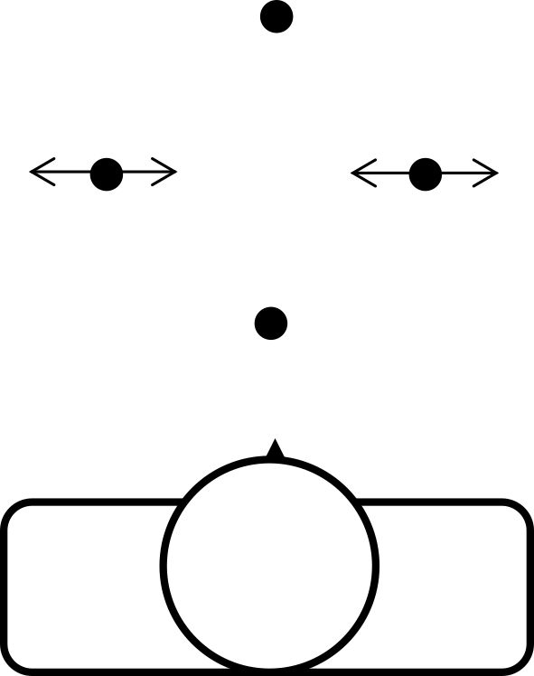
Figure 2

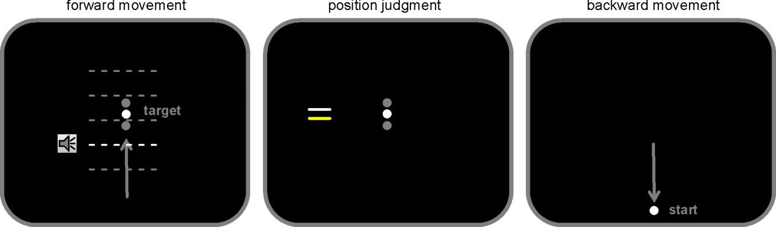

Figure 3
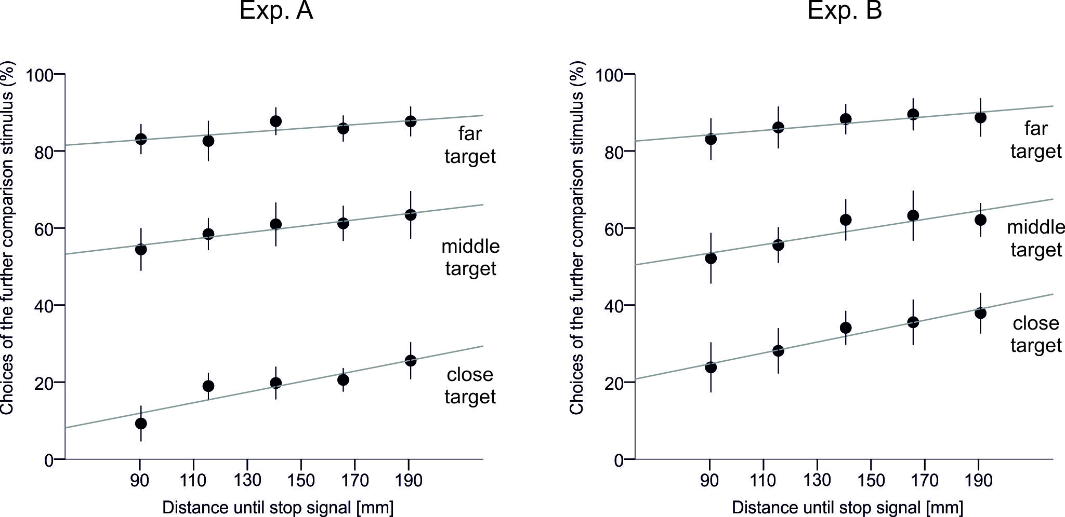

Figure 4
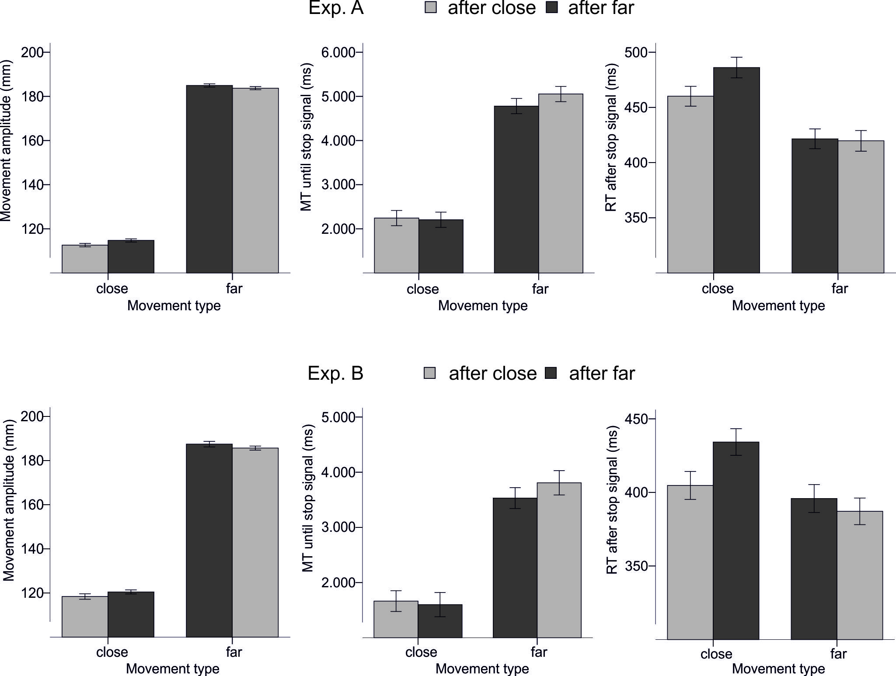

Figure captions

Figure 1. Measuring distance perception by a method of adjustment (see main text for further details).

Figure 2. Basic procedure of the present study. Participants were asked to move their right hand holding a stylus from a start position in the direction of a target position and to stop the movement after they heard a tone. Then, the current target position (that was still visible) was judged by the choice of one of two comparison stimuli (i.e., lines) before the stylus was moved back to the start. There were three possible target locations (white dot indicates a currently visible target) and five possible positions at which stop signals occurs (delineated by the dashed lines). Movements were performed on a horizontal plane below a mirror that prevented the vision of the hand and stylus. In Exp. B, the current position of the stylus was not visible during the forward movement. In Exp. A, in contrast, continuous visual feedback of the stylus position was provided.

Figure 3. Percentage choices of the further comparison line for the three targets and five movement conditions (untransformed). Error bars reflect within participants confidence intervals (95%) computed according to Cousineau (2005).

Figure 4. Movement amplitude (left), movement time until the stop signal (middle) and reaction time after the stop signal (right) depending on whether the previous trial contained the same or a different stop category. Error bars reflect within participants confidence intervals (95%) computed according to Cousineau (2005).

Acknowledgments
This research was supported by grant KI 1620/1-1 awarded to W. Kirsch by the German Research Council (DFG).

APPENDIX
Mean movement amplitude in Experiment A and Experiment B (in mm). Standard deviations are in parentheses.

EXP. A | Distance until stop signal
 | 90.4 mm | 115.5 mm | 140.6 mm | 165.7 mm | 190.8 mm
close target | 102.6 (4.8) | 124.9 (3.5) | 147.1 (2.1) | 172.2 (1.9) | 196.4 (1.7)
middle target | 102.5 (4.7) | 125.4 (3.8) | 147.2 (2.2) | 172.1 (2.2) | 196.2 (1.6)
far target | 102. 8 (4.6) | 125.2 (3.2) | 147.7 (2.3) | 172.1 (1.9) | 196.1 (1.6)
EXP. B
close target | 109.8 (6.1) | 129.9 (4.7) | 151.7 (4.6) | 174.2 (3.5) | 198.1 (3.2)
middle target | 108.9 (6.3) | 130.1 (5.2) | 151.4 (4.6) | 174.3 (3.3) | 198.4 (3.6)
far target | 110.0 (6.4) | 130.1 (4.9) | 151.4 (3.9) | 174.2 (4.1) | 198.1 (3.4)

Address correspondence to [kirsch@psychologie.uni-wuerzburg.de]
Participants usually press it by the index finger.
This value took into account a delay between the stop signal and the end point of the movement as well as the expected variability in movement velocity across the participants.
One participant of Exp. B completed four instead of three blocks. Excluding this participant from the analyses did not change the results substantially.
This value seemed appropriate in the present context because it reduced an impact of possible small deviations of the stylus from the start position before target movement.
Here, the middle stop condition was excluded from the analyses. Note, an impact of this condition is still present in the data (of switch trials). This impact, however, can be assumed to be comparable for the closer and further stop categories.
For far movements, this effect was reduced in Exp. B and disappeared in Exp. A (see Fig. 4). This slight deviation from the overall pattern might be related to a type of ceiling effect because the probability of stopping increased with an increase in stop distance. In a similar vein, a smaller difference in movement times for short movements as compared with far movements might be due to a type of floor effect.

